GLOBAL MALNUTRITION TREND (1983-2019)

Documentation

Global Malnutrition refers to the widespread presence of malnutrition, which is a condition that results from eating a diet in which one or more nutrients are either not enough or are too much such that diet causes health problems.

Global malnutrition trends (1983-2019) A using POWER BI Analysis

Import the data Into POWER BI:

1.Open POWER BI Desktop

2. Import Data:

Go to ‘Home’ _Get data _’Text/csv’

Select CSV file and LOAD the data into POWER BI

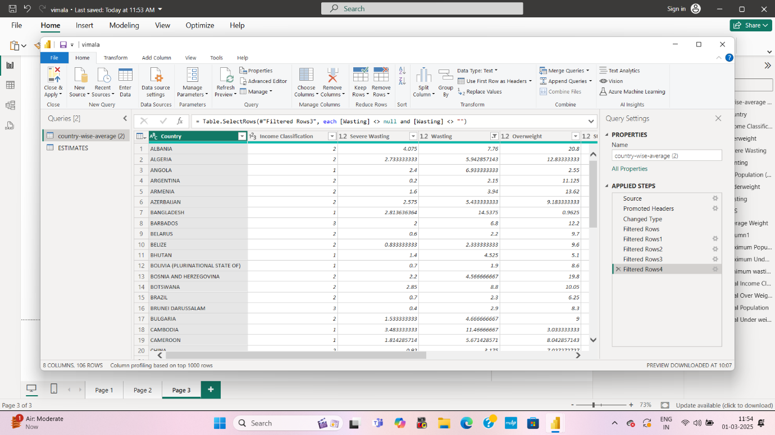

Open POWER Quary Editor:

* Go to ‘Home’ _ ’Transform data’

And clean the data , remove duplicates files , remove unnecessary columns and rows .

Close and Apply:

* Close power Quary editor and Apply changes

Dashboard layout:

TITLE:

Add a textbox with the title “GLOBAL MALNUTRITION TRENDS 1983-2019”

Create New Measures using some DAX function

1. Total U5 population=sum(‘Table’[U5 population])

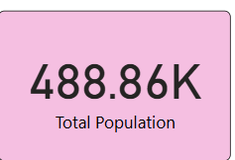

1. Total under weight =sum(‘table’[underweight])

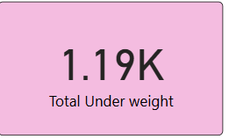

1. Avg over weight =AVERAGE(‘table’[overweight])
2. Minimum wasting =min(‘table’[wasting])

CREATE VISUALIZATION:

1 . take a number cards from visualization

Total population, Total over weight, Total underweight, total income classification.

This cards shows correct figures.

2. and takes a Area char from charts

This chart shows sum of over weight by country

3 . takes line chart from charts

This chart shows over weight and under weight

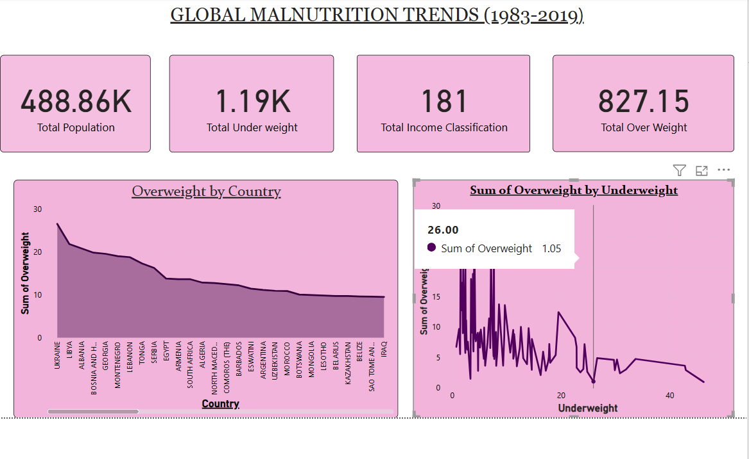

This is 1st page

2nd VISUALIZATION:

* Takes a Ribbon chats from charts

This ribbon chart shows over weight by U5 population

* Takes a GAUGE from charts

This shows sum of under weight by average weight

* Takes number card from charts

This card shows average weight .

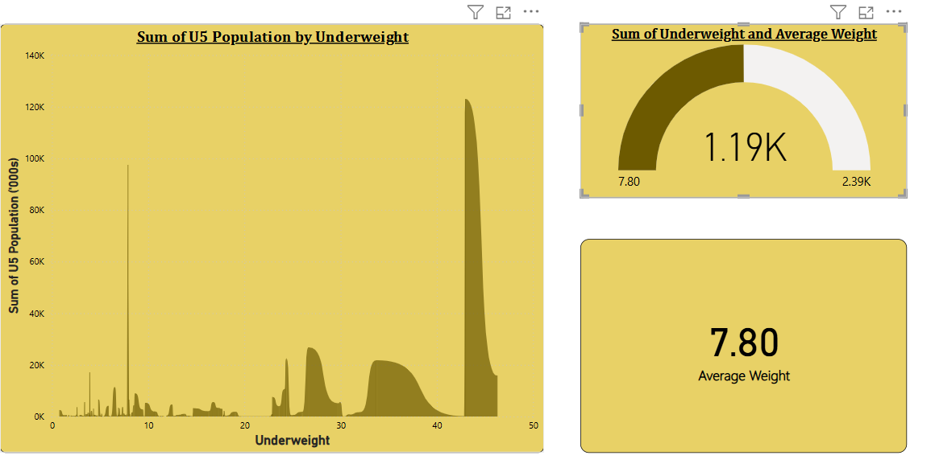3rd VISUALIZATION:

* Takes pie chart from chart

This chart shows under weight by income classification

* Take donut chart form chart

This chart shows over by income classification

* Takes a stacked column chart from charts

This chart shows over weight by under weight and wasting

